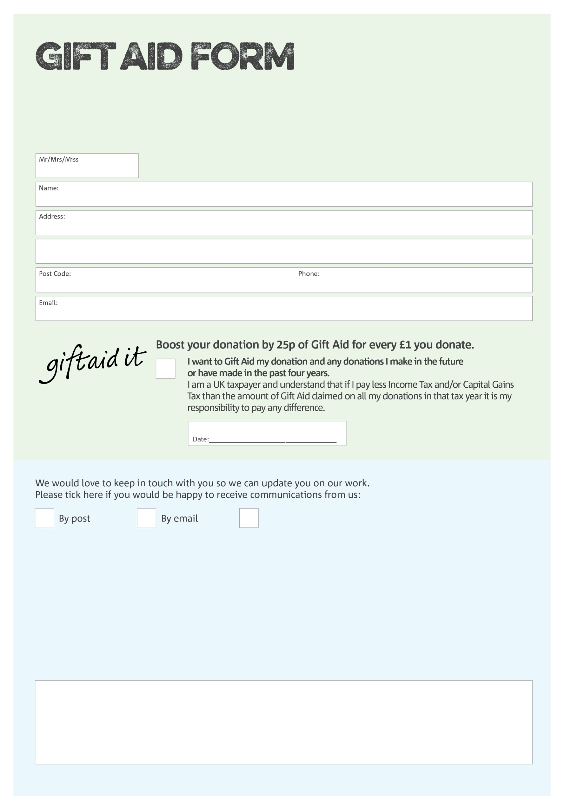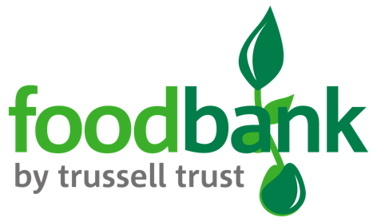

By filling in this form Chalk Farm Foodbank will receive an extra 25p for every £1 you give at no extra cost to you. Thank you!

**Data protection**

Chalk Farm Foodbank is committed to protecting your privacy and will process your personal data in accordance with the Data Protection Regulation 2018. Your details will be kept safe and secure and only used by us or those who work for us and will not be shared, sold or rented to third parties for marketing purposes. Chalk Farm Foodbank collects information to keep in touch with you and supply you with information relating to our work. We may use information and data you provide for analysis research or screening purposes in order to help us understand our supporters so we can save resources and deliver the best possible service. A full data privacy statement for finacical donors is available from foodbank on request

You can change your preferences any time by contacting us on 0207 483 3763 or emailing us at

info@chalkfarm.foodbank.org.uk

I do not wish to receive future communications from Chalk Farm Foodbank

We would love to know why you have chosen to donate to Chalk Farm Foodbank. If you would like to share your motivation let us know below:

Charity Number 1120790. Registered in England and Wales